OPERATIONAL PLAN FOR TEMPORARY BUS PICKUP AND DROPOFF FOR THOMAS JEFFERSON MIDDLE SCHOOL DURING CONSTRUTION OF THE NEW ELEMENTARY SCHOOL

I. Location of temporary bus dropoff/pickup area – as shown in the sketch below, the temporary bus dropoff/pickup area will be curbside in the existing parking lane along S. 2nd St, on the school side of the street.
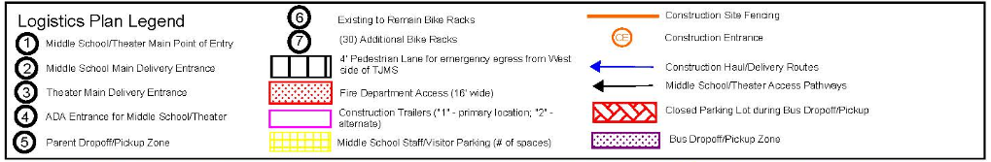
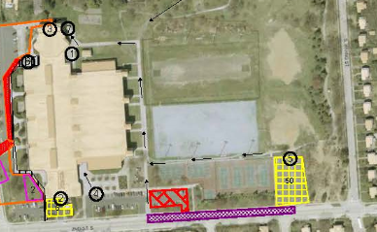

II. Duration of time required for the temporary bus dropoff/pickup – the new permanent bus dropoff/pickup will be available for the Fall 2018 school year, so the temporary dropoff/pickup will be needed only for summer school in summer of 2017 and for the regular 2017-18 school year.
III. Capacity of temporary bus dropoff/pickup queue – the queue is designed to accommodate 12 regular size school buses, each of 40’ in length. With 12 buses @ 40’, and leaving adequate space between buses, the queue length required is approximately 500’. To accommodate 12 buses the queuing area in the existing parking lane on 2nd St. S. will extend from the community center parking lot middle entry apron to the curb nub adjacent to S. Irving St. There are 3 parking lot entry aprons within the queuing area that buses will need to keep clear of.
IV. Morning Dropoff operation – school starts at 7:50am, buses are staggered in the morning and arrive in ones or twos between approximately 7:05am and 7:50am. Buses take about 2-3 minutes each to unload. During the morning dropoff period, school staff will barricade off the east community center parking lot so that traffic cannot move through the lot, thereby allowing children to cross the lot and head up the sidewalk to the temporary main school entry on the east side of the building. School staff will be stationed on the sidewalk on the school side of S. 2nd St to assist with dropoff. Buses will use their stop arms and lights when dropping off and all traffic on S. 2nd St will be required to stop during drop off for each bus. At times during inclement weather the school may experience a 2 hour delay, at which point school starts at 9:50am. Bus dropoff times would be adjusted accordingly.

V. Afternoon Pickup operation – normal school dismissal is at 2:24pm. Early release is at 11:54am (approximately 5 days per year). 4 late buses arrive at 4:21pm. In the afternoon, multiple buses queue at the same time in order to be prepared for bulk student dismissal. Once dismissed, it takes about 10 minutes to load the buses and send them on their way. Similar to morning dropoff, school staff will barricade off the east community center parking lot during afternoon pickup so that traffic cannot move through the lot, thereby allowing children to cross the lot from the school and board their buses. School staff will be stationed on the sidewalk on the school side of S. 2nd St to assist with pickup. Buses will use their stop arms and lights when picking up and all traffic on S. 2nd St will be required to stop during the pickup period.

VI. Signage required – in order to accommodate the temporary bus dropoff/pickup area, signage that restricts parking during bus dropoff and pickup will be installed along the length of the queuing area at the planting strip in the right of way. County Transportation Staff will install signage the week of June 19th. Two (2) no parking zones will be signed in the bus queuing area, one to accommodate regular buses and one to accommodate both regular and late buses. The queue zone closest to the main entry will be signed “No Parking Except School Buses 7am-8am, 1pm-3pm, Mon-Fri” and will also include a Tow-Away Plaque and a Green Sign indicating “Parking All Other Times”. The queue zone furthest from the main entry will be signed “ No Parking Except School Buses 7am-8am, 1pm-4:45pm, Mon-Fri” and will also include a Tow-Away Plaque and a Green Sign indicating “Parking All Other Times”. The Tow-Away plaque will be police enforced ensuring that this area is cleared out during the times posted. If violations occur, School Staff or APS Transportation Staff can also notify the police.

V. Special Conditions – for early release dates, School Staff will need to contact County Transportation staff 48 hours in advance so that County staff can install temporary signage that changes the no-parking hours in the bus queue zone to align with the hours for early release. For delayed start of school due to inclement weather conditions, School Staff will need to place cones in the bus queue zone the morning of the incident during the regular no-parking hours, in order to reserve the bus queue zone for the delayed start.

VI. Special Needs Buses – special needs buses will be permitted to use the community center parking lot for dropoff and pickup. The special needs entrance will be the main community center entrance. Special needs students will need to be escorted from the community center entrance, through the game room , to the elevator in the game room so that they may access the main level of the school.

